Chapter 1 Atomic Structure and the Periodic Table name:
1. 了解亚原子粒子的基本性质（质子、中子、电子的电荷与位置）
Proton: +1 charge, located in nucleus; Neutron: 0 charge, located in nucleus; Electron: −1 charge, located in shells
Atomic number (Z) = number of protons; Mass number (A) = protons + neutrons
Neutral atom: protons = electrons; Ion: protons ≠ electrons

1. Which of the following correctly describes the location and charge of a proton? （ ）
A nucleus, +1
B nucleus, 0
C shell, +1
D shell, −1

2. An atom of 31P contains （ ）
A 15 protons, 15 neutrons, 15 electrons
B 15 protons, 16 neutrons, 15 electrons
C 16 protons, 15 neutrons, 16 electrons
D 15 protons, 31 neutrons, 15 electrons

3. An atom has 24 protons, 28 neutrons, and 21 electrons. Which is true? （ ）
A It is a neutral atom of Cr-52.
B It is a Cr³⁺ ion with mass number 52.
C It is a Cr³⁺ ion with mass number 49.
D It is an anion of chromium.

4. Chromium-53 is an isotope of chromium.
How many protons, neutrons and electrons does a neutral atom of this isotope have? （ ）
A. 53 protons, 24 neutrons, 53 electrons
B. 24 protons, 53 neutrons, 24 electrons
C. 26 protons, 24 neutrons, 24 electrons
D. 24 protons, 29 neutrons, 24 electrons

5. What is the correct number of subatomic particles in a phosphide ion, P³⁻? （ ）
A. 15 protons, 16 neutrons, 18 electrons
B. 15 protons, 16 neutrons, 15 electrons
C. 16 protons, 15 neutrons, 18 electrons
D. 15 protons, 16 neutrons, 12 electrons

6. Three ions of different elements are shown above. Which of the following statements is/are correct? （ ）
I. All three ions have the same number of electrons.
II. None of the ions have the same number of neutrons as each other.
III. Cl⁻ and K⁺ have the same total number of subatomic particles.
A. Option A
B. Option B
C. Option C
D. Option D

2. 掌握同位素的概念、表示方法及平均相对原子质量的计算
Isotopes: atoms of the same element (same Z) with different numbers of neutrons (different A)
Isotopes have identical chemical properties (same electron configuration) but different physical properties (different mass)
Average atomic mass = Σ(isotope mass × fractional abundance)

1. Which of the following pairs represent isotopes of the same element? （ ）
A ¹⁴C and ¹⁴N
B ⁴⁰Ar and ⁴⁰K
C ³⁵Cl and ³⁷Cl
D ²³Na and ²⁴Mg

2. The mass spectrum of silicon shows peaks at m/z = 28 (92.2%), 29 (4.7%), and 30 (3.1%).
What is the average atomic mass? （ ）
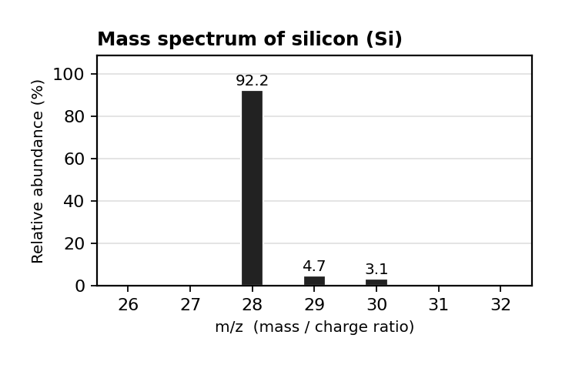
图 C₁-1：硅的质谱图（对应第 2 考点 MCQ2）
A 28.0 amu
B 28.1 amu
C 29.0 amu
D 29.5 amu

3. The mass spectrum of Br shows two peaks of nearly equal intensity at m/z = 79 and 81. This means: （ ）
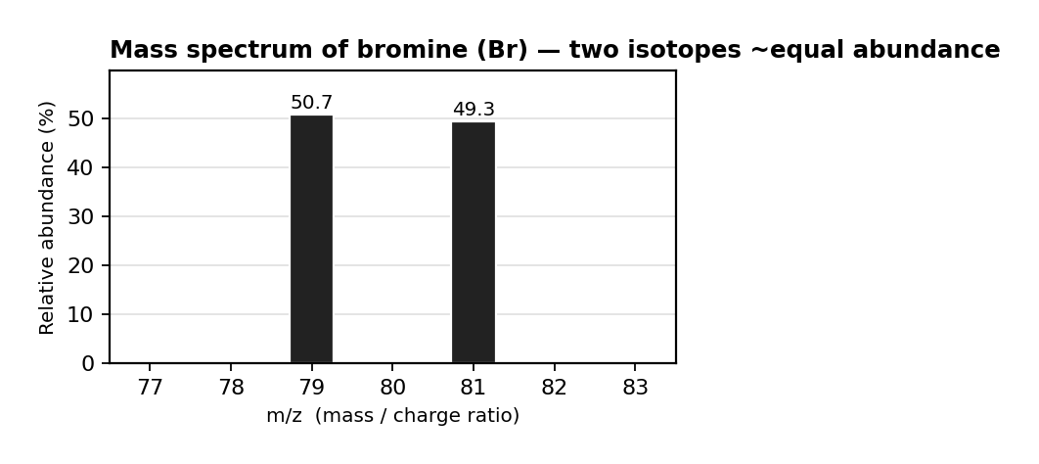
图 C₁-2：溴的质谱图（对应第 2 考点 MCQ3）
A bromine has equal protons and neutrons.
B ⁷⁹Br and ⁸¹Br have ~equal natural abundance.
C bromine exists as a diatomic molecule.
D bromine has two different IE values.

4. An element consists of two isotopes ⁶⁹X and ⁷¹X, whose abundances are 60% and 40% respectively.
What is the relative atomic mass of element X? （ ）
A. Option A
B. Option B
C. Option C
D. Option D

5. The mass spectrum of element X is shown above. Which of the following is true? （ ）
A. Element X is germanium.
B. X has a relative atomic mass between 71 and 72.
C. The most abundant isotope of X contains a total of 71 protons and neutrons.
D. The spectrum shows the abundance of the isotope ⁷²X is greater than the abundance of the ⁷⁰X.

6. Element Z has three isotopes: ⁷⁰Z, ⁷²Z and ⁷⁴Z.
They occur naturally with abundances of 24.4%, 32.4% and 43.2%, respectively.
What is the average atomic mass of element Z? （ ）
A. Option A
B. Option B
C. Option C
D. Option D

7. A sample of neon contains the isotopes ²⁰Ne and ²¹Ne.
The average atomic mass of the neon sample is 20.2.
What is the percentage of ²¹Ne atoms in the sample of neon? （ ）
A. Option A
B. Option B
C. Option C
D. Option D

8. Iron has many different naturally occurring isotopes: ⁵⁴Fe (5.845%, 53.9396), ⁵⁶Fe (91.754%, 55.9349), ⁵⁷Fe (2.119%, 56.9354), ⁵⁸Fe (0.282%, 57.9333).
What is the average atomic mass of iron? （ ）
A. Option A
B. Option B
C. Option C
D. Option D

9. A sample of strontium was analysed by mass spectroscopy.
Some of the relative abundances of each isotope are shown: m/z = 84 (0.56%), m/z = 86 (to be found), m/z = 87 (to be found), m/z = 88 (82.58%).
Strontium has a relative atomic mass of 87.71.
What percentage abundance values below are correct for strontium-86 and strontium-87 respectively? （ ）
A. Option A
B. Option B
C. Option C
D. Option D

图 C₁-5：镁的质谱图（对应第 2 考点 MCQ10，含 Mg²⁺ 峰）
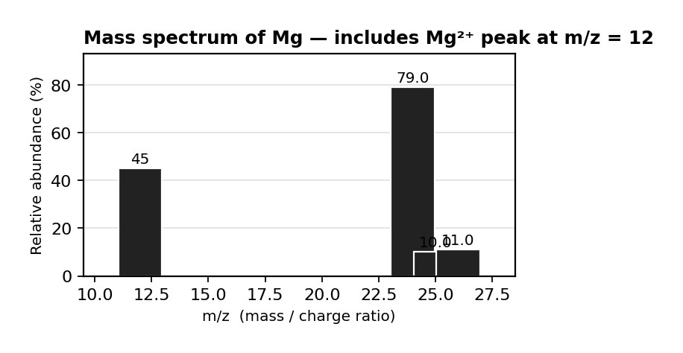

10. The mass spectrum of a sample of element X is shown above.
There are four peaks at m/z = 12, 24, 25 and 26.
Which of the following statements is/are correct? 1.
The peak at m/z = 12 is due to a ²⁴X²⁺ ion. 2.
The peak at m/z = 12 is due to an ion with a total of 12 neutrons and protons. 3.
The relative atomic mass of element X will be between 12 and 24. （ ）
A. Option A
B. Option B
C. Option C
D. Option D

11. Bromine has two stable isotopes: ⁷⁹Br (50.7%) and ⁸¹Br (49.3%).
(a) State the number of protons, neutrons, and electrons in ⁸¹Br. [1 mark]
(b) Calculate the average atomic mass of bromine. [2 marks]
(c) The mass spectrum of Cl₂ shows peaks at m/z = 70, 72, and 74 with intensities ~9:6:1. Explain why three peaks are observed and the 9:6:1 ratio. [4 marks]
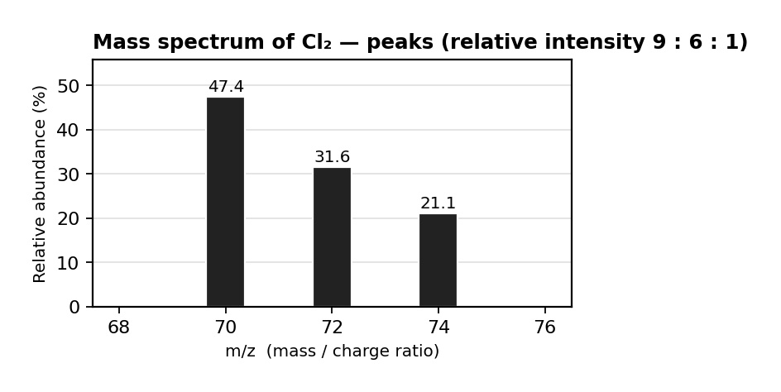

12. Neon gas is analyzed by mass spectrometry. Peaks at m/z = 20, 21, 22 with abundances 90.5%, 0.3%, 9.2%.
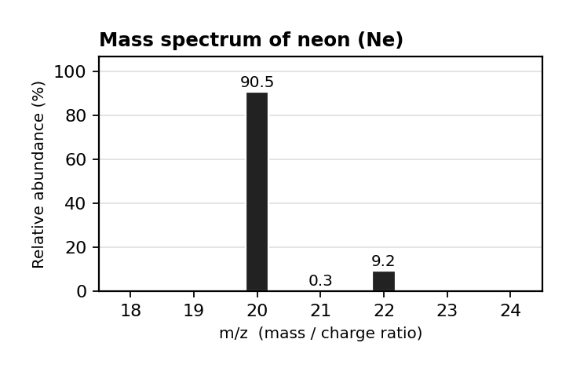
(a) Calculate the average atomic mass of neon. [2 marks]
(b) How many neutrons are in the most abundant isotope? [1 mark]
(c) All three isotopes have identical chemical properties. Explain why. [2 marks]

3. 掌握电子排布——基态、激发态、离子的电子排布
Electrons fill orbitals in order of increasing energy: 1s < 2s < 2p < 3s < 3p < 4s < 3d < 4p
Each orbital holds max 2 electrons with opposite spins
When filling degenerate orbitals (same energy, e.g. 2pₓ, 2p_y, 2p_z), electrons occupy each orbital singly before pairing
Ground state: lowest energy arrangement; Excited state: an electron is promoted to a higher-energy orbital
Ions: electrons are lost from the highest principal energy level first (e.g. 4s before 3d for transition metals)
Exceptions: Cr = [Ar] 4s¹ 3d⁵ and Cu = [Ar] 4s¹ 3d¹⁰ (half-filled / fully-filled d sublevel is more stable)

1. Which electron configuration represents an atom in an excited state? （ ）
A 1s² 2s² 2p⁶ 3s² 3p⁶
B 1s² 2s² 2p⁶ 3s² 3p⁶ 4s¹
C 1s² 2s² 2p⁵ 3s¹
D 1s² 2s² 2p⁶ 3s² 3p⁴

2. The ground-state electron configuration of Fe²⁺ (Z = 26) is （ ）
A [Ar] 3d⁶
B [Ar] 4s² 3d⁴
C [Ar] 4s¹ 3d⁵
D [Ar] 3d⁵ 4s¹

3. The complete electron configuration of Co³⁺ (Z = 27) is （ ）
A [Ar] 3d⁶
B [Ar] 4s² 3d⁵
C [Ar] 3d⁷ 4s¹
D [Ar] 4s¹ 3d⁵

4. How many unpaired electrons are present in a ground-state oxygen atom (Z = 8)? （ ）
A 0
B 1
C 2
D 3

5. Which ground-state atom has exactly three unpaired electrons? （ ）
A B (Z = 5)
B N (Z = 7)
C O (Z = 8)
D F (Z = 9)

6. A student proposes [Ar] 3d⁴ 4s² for Cr (Z = 24). Is this correct? （ ）
A Yes, electrons fill in order of n+l.
B Yes, all sublevels follow the energy order.
C No, the correct configuration is [Ar] 4s¹ 3d⁵ (half-filled d sublevel stability).
D No, the correct configuration is [Ar] 4s² 3d⁴.

7. Which electron configuration violates the rule that electrons in degenerate orbitals should be unpaired before pairing? （ ）
A 1s² 2s² 2p³ (one electron in each 2p orbital)
B 1s² 2s² 2p⁴ (one 2p orbital has a pair, others have one each)
C 1s² 2s² 2p⁴ (two 2p orbitals paired, one empty)
D 1s² 2s² 2p⁶

8. 1s²2s²2p⁶ Which of the following species has the electron configuration shown above? （ ）
A. Option A
B. Option B
C. Option C
D. Option D

9. Which statement is correct? （ ）
A. Oxygen has 6 electrons.
B. Chlorine has 17 valence electrons.
C. Calcium has 12 p electrons.
D. Copper has 9 d electrons.

10. A charged particle has the electronic configuration [Ar]3d³. What is the identity of the particle? （ ）
A. Option A
B. Option B
C. Option C
D. Option D

11. This question is about electron configurations.
(a) Write the complete ground-state electron configuration for: (i) S (Z=16), (ii) Ca²⁺ (Z=20), (iii) Fe (Z=26). [3 marks]
(b) Write the abbreviated electron configuration for Br (Z = 35). [1 mark]
(c) The configuration 1s² 2s² 2p⁶ 3s¹ can represent an excited state of Mg or the ground state of another species. (i) Explain why this is excited for Mg. (ii) Identify the species with this as ground state. [3 marks]
(d) A student claims that for transition metal ions, electrons are always lost from (n−1)d before ns. Do you agree? Justify using Cr²⁺. [2 marks]

4. 掌握光电子能谱（PES）的解读——峰的位置、强度与电子排布的对应关系
PES (Photoelectron Spectroscopy): measures binding energy of electrons in each sublevel
Peak position (x-axis): binding energy — lower BE = outer electrons (easier to remove); higher BE = inner electrons
Peak intensity (height/area): number of electrons in that sublevel
Order of BE: 1s > 2s > 2p > 3s > 3p > 4s > 3d (inner electrons held more tightly)

1. The PES of an element shows peaks at binding energies of 0.58, 3.2, 24, and 121 MJ/mol with relative intensities of 1:3:2:2.
The element is most likely （ ）
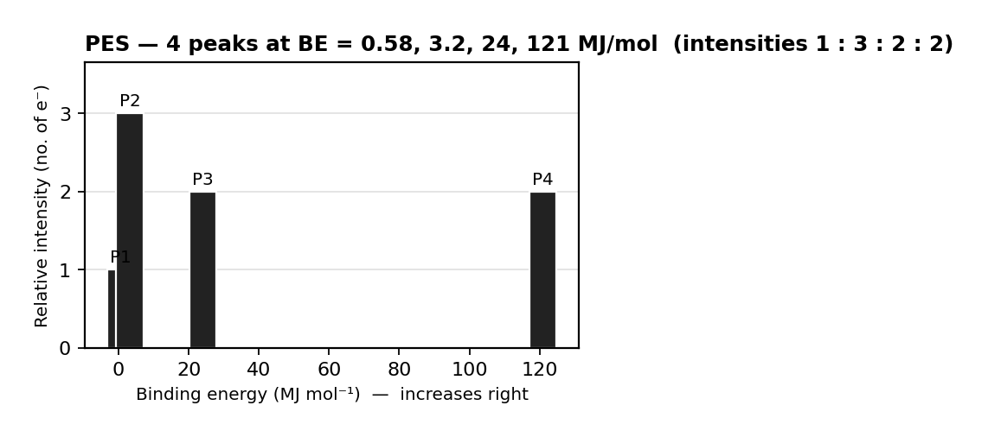
图 C₁-7：PES 数据（对应第 4 考点 MCQ1，BE = 0.58/3.2/24/121 MJ·mol⁻¹）
A Li
B B
C O
D Ne

2. A PES spectrum shows four peaks with relative intensities 2:2:6:1. The element is most likely （ ）
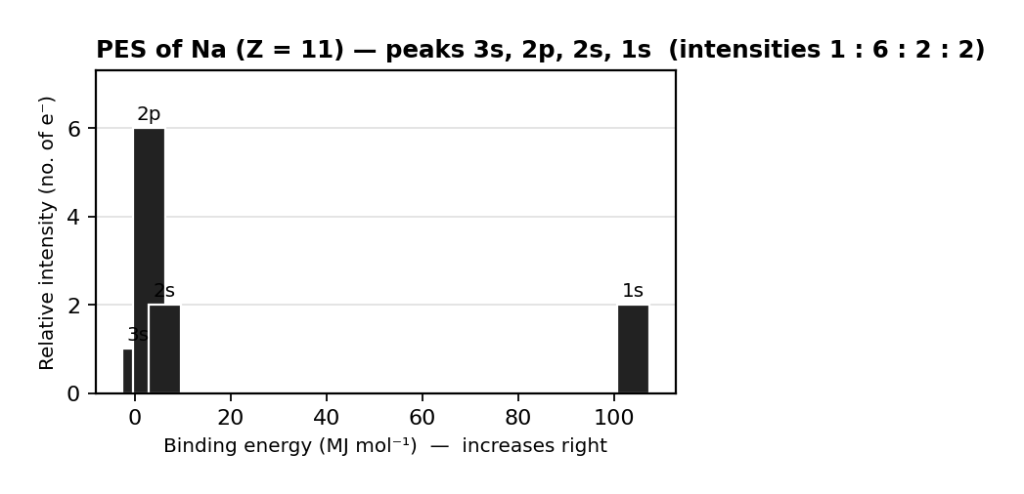
图 C₁-6：Na 的光电子能谱（对应第 4 考点 MCQ2，强度比 2:2:6:1）
A Na (Z = 11)
B Mg (Z = 12)
C Al (Z = 13)
D Si (Z = 14)

3. The photoelectron spectrum of an unknown element is shown above.
Based on the binding energies and the number of peaks, which of the following elements does the spectrum represent? （ ）
A. Option A
B. Option B
C. Option C
D. Option D

图 C₁-9：钪的光电子能谱（对应第 4 考点 MCQ4，[Ar]4s²3d¹）
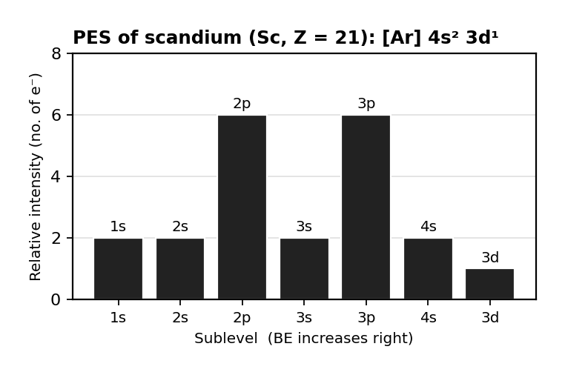

4. Based on the photoelectron spectrum of scandium shown above, what is the most accurate reason scandium typically forms a 3+ ion rather than a 2+ ion? （ ）
A. Removing two electrons reduces spin-pairing repulsion in the 4s sublevel, but completely emptying the 4s sublevel is more energetically favorable.
B. The energy required to remove an electron from the 3d sublevel is comparable to that of the 4s sublevel, whereas significantly more energy is needed to remove electrons from the 3p sublevel.
C. Scandium belongs to Group 3, and atoms will only lose electrons until they achieve a noble gas electron configuration.
D. The energy released by removing three electrons is greater than that released by removing two electrons.

5. PES data for an element:
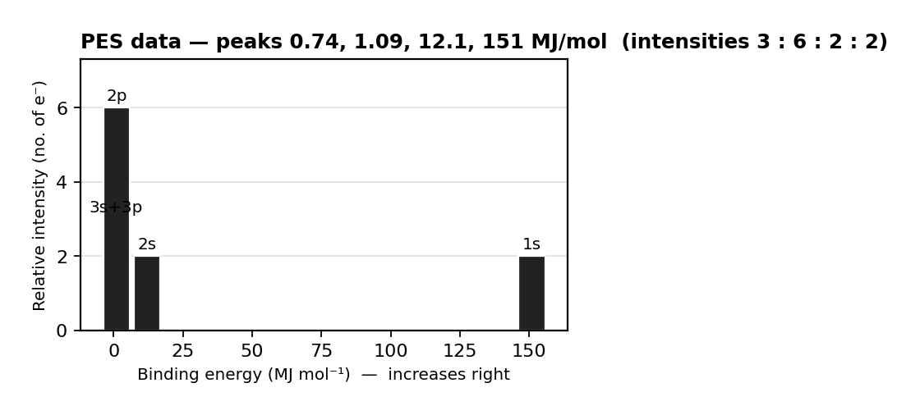
图 C₁-8：PES 数据（对应第 4 考点 FRQ5，Al 元素）
(a) How many electrons are in the sublevel corresponding to Peak 4 (intensity 3)? [1 mark]
(b) Identify the element (peaks: 151 MJ/mol intensity 2; 12.1 intensity 2; 1.09 intensity 6; 0.74 intensity 3). Show reasoning. [2 marks]
(c) Which peak corresponds to 1s electrons? Justify. [1 mark]

6. The PES of an element shows peaks with binding energies of 0.52 MJ/mol (intensity 1), 3.67 MJ/mol (intensity 4), and 25.6 MJ/mol (intensity 2).
(a) How many different sublevels contain electrons? [1 mark]
(b) Identify the element. Justify. [2 marks]
(c) The PES of Si shows peaks for 1s, 2s, 2p, and 3s. The 3p peak is missing. (i) Draw it and state its relative intensity. (ii) Explain why 3p BE is lower than 3s. [4 marks]

5. 掌握周期趋势——原子半径和离子半径
Atomic radius: decreases across a period (L→R) due to increasing effective nuclear charge; increases down a group due to more shells
Ionic radius: cations < parent atom (lose shell); anions > parent atom (added e⁻ repulsion)
Isoelectronic species: same e⁻ count — smaller nuclear charge = larger radius (less nuclear attraction)

1. Which best explains why atomic radius decreases from Na to Cl across Period 3? （ ）
A The number of neutrons increases.
B Effective nuclear charge increases while electrons are added to the same n level.
C The principal quantum number decreases.
D Electron-electron repulsion decreases.

2. Which has the largest ionic radius? (all are isoelectronic) （ ）
A Na⁺
B Mg²⁺
C F⁻
D O²⁻

3. Which correctly orders S²⁻, Cl⁻, K⁺, Ca²⁺ (all isoelectronic) by increasing ionic radius? （ ）
A Ca²⁺ < K⁺ < Cl⁻ < S²⁻
B S²⁻ < Cl⁻ < K⁺ < Ca²⁺
C K⁺ < Ca²⁺ < S²⁻ < Cl⁻
D Cl⁻ < S²⁻ < Ca²⁺ < K⁺

4. Which element has the smallest atomic radius? （ ）
A. Option A
B. Option B
C. Option C
D. Option D

5. Various trends can be observed down groups and across periods in the Periodic Table.
Which statement about these trends is true? （ ）
A. Ionization energy increases going down a group.
B. Atomic radius generally decreases across a period.
C. Electronegativity decreases across a period.
D. Electron affinity generally increases down a group.

6. Consider the following ions: S²⁻, Cl⁻, K⁺, Ca²⁺.
Which of the following arranges the ions in order of increasing ionic radius? （ ）
A. Ca²⁺ < K⁺ < Cl⁻ < S²⁻
B. S²⁻ < Cl⁻ < K⁺ < Ca²⁺
C. K⁺ < Ca²⁺ < Cl⁻ < S²⁻
D. Cl⁻ < S²⁻ < Ca²⁺ < K⁺

7. Answer the following about atomic and ionic radii.
(a) Explain why the atomic radius of Cl is smaller than that of Na. [2 marks]
(b) Explain why the radius of S²⁻ is larger than that of S. [2 marks]
(c) A student argues: "K⁺ and Cl⁻ are isoelectronic, so they should have the same ionic radius." Do you agree? Justify. [2 marks]

6. 掌握周期趋势——电离能（IE）及其异常
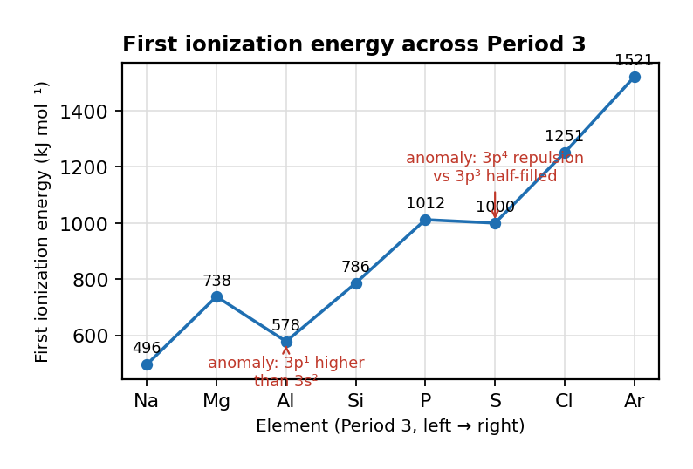
图 C₁-10：第三周期第一电离能趋势（对应第 6 考点）
Ionization Energy (IE): energy required to remove an electron from a gaseous atom/ion
Trend: increases across a period (L→R) due to increasing effective nuclear charge; decreases down a group due to increased shielding and distance
Anomalies: IE1(Be) > IE1(B) — 2p electron is higher energy than 2s; IE1(N) > IE1(O) — 2p³ half-filled stability vs 2p⁴ e⁻-e⁻ repulsion
Successive IE: large jump when removing core electron (different shell) — identifies group number

1. Which element has the highest first ionization energy? （ ）
A Li
B Na
C K
D Rb

2. IE1 of Mg (738 kJ/mol) is greater than Al (578 kJ/mol). This is best explained by: （ ）
A Mg has greater nuclear charge.
B The electron removed from Mg is in 3s; from Al in higher-energy 3p.
C Al has more electron repulsion.
D Mg is a smaller atom.

3. IE1 of P (1012 kJ/mol) > IE1 of S (1000 kJ/mol). This anomaly is best explained by: （ ）
A P has a greater nuclear charge.
B The electron from S comes from a doubly occupied 3p orbital (greater e⁻-e⁻ repulsion).
C S has a larger atomic radius.
D P has more unpaired electrons.

4. Which is the correct equation for the first ionization energy for magnesium? （ ）
A. Mg (g) → Mg²⁺ (g) + 2e⁻
B. Mg⁺ (g) → Mg²⁺ (g) + e⁻
C. Mg (g) → Mg⁺ (g) + e⁻
D. Neither; the trend is reversed in Period 3

5. Which statement about ionization energy is true? （ ）
A. It is the energy required to add an electron to an atom or ion in the gaseous state and is always endothermic.
B. It is the energy required to add an electron to an atom or ion in the gaseous state and is always exothermic.
C. It is the energy required to remove an electron from an atom or ion in the gaseous state and is always endothermic.
D. It is the energy required to remove an electron from an atom or ion in the gaseous state and is always exothermic.

6. The table below lists pairs of elements and their relative first ionization energies.
Which pair correctly identifies the correct relative ionization energy? （ ）
A. Be (higher IE due to filled 2s subshell stability)
B. B (lower IE due to 2p electron being higher energy and shielded)
C. Both have the same first ionization energy
D. Neither; the trend is reversed in Period 3

7. Successive ionization energies for an element, X, are shown: 1st = 736, 2nd = 1450, 3rd = 7740, 4th = 10500, 5th = 13600 kJ/mol.
What is the most likely formula for the ion of X? （ ）
A. Be (higher IE due to filled 2s subshell stability)
B. B (lower IE due to 2p electron being higher energy and shielded)
C. Both have the same first ionization energy
D. Option D

8. Which of the following identifies the most probable value for the fourth ionization energy of boron and provides the best justification? （ ）
A. 4860 kJ/mol because the electron removed during the fourth ionization is a core electron.
B. 4860 kJ/mol because the electron removed during the fourth ionization is a valence electron.
C. 25025 kJ/mol because the electron removed during the fourth ionization is a core electron.
D. 25025 kJ/mol because the electron removed during the fourth ionization is a valence electron.

9. The first six ionization energies for elements X and Y are shown (kJ/mol). X: 1313, 3373, 6050, 8400, 22800, 32600; Y: 1086, 2353, 4620, 6223, 37831, 47277.
Based on the data, which of the following correctly identifies elements X and Y, respectively? （ ）
A. Option A
B. Option B
C. Option C
D. Option D

10. The first four ionization energies (kJ/mol) of a Period 3 element are:
(a) Identify the element. Justify using the IE data (IE1=738, IE2=1451, IE3=7733, IE4=10543). [2 marks]
(b) Explain the large jump from IE2 to IE3. [2 marks]

11. The table shows IE1 of Group 1 elements (kJ/mol):
(a) Explain the trend in IE1 down Group 1 (Li=520, Na=496, K=419, Rb=403, Cs=376). [2 marks]
(b) Would you expect IE1 of Fr to be greater or less than 376 kJ/mol? Justify. [1 mark]

12. The IE2 of Na (~4560 kJ/mol) is much larger than that of Mg (~1450 kJ/mol).
(a) Explain why, referencing electron configurations. [2 marks]

Group 1 IE1 data:
Li | Na | K | Rb | Cs
520 | 496 | 419 | 403 | 376

7. 掌握 Coulomb 定律及其在解释周期趋势中的应用
Coulomb's law: F ∝ q₁q₂/r² — force between nucleus and electron depends on charges and distance
Down a group: r increases (more shells) → weaker attraction → lower IE, larger radius
Across a period: effective nuclear charge increases (more protons, same shell) → stronger attraction → higher IE, smaller radius
Shielding: inner-shell electrons reduce the effective nuclear charge felt by valence electrons

1. Coulomb's law: F ∝ q₁q₂/r². Why is the valence electron in K more easily removed than in Na? （ ）
A K has more protons.
B The valence electron in K is further from the nucleus (larger r).
C K has more neutrons.
D The valence electron in K has a smaller charge.

2. The effective nuclear charge for K's valence electron is less than Na's because: （ ）
A K has lower nuclear charge.
B K's valence e⁻ is in n=4 with more inner-shell shielding.
C K has smaller atomic radius.
D K has more neutrons.

3. What is the equation for Coulomb's Law? （ ）
A. F = G·m₁·m₂/r²
B. F = k·q₁·q₂/r²
C. E = h·f
D. KE = ½mv²

图 C₁-11：离子晶格示意图与 Coulomb 定律（对应第 7 考点 MCQ4）
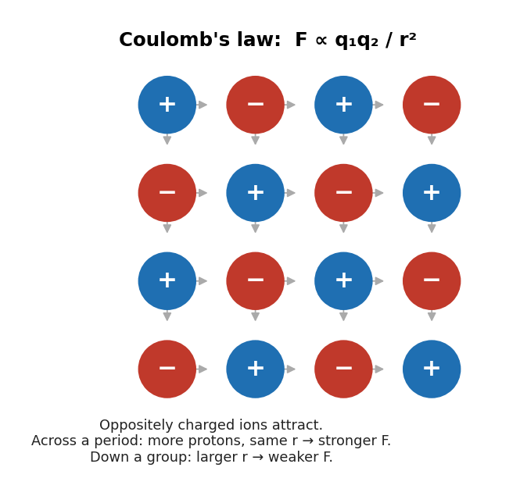

4. The diagram shows the crystal structure of an ionic lattice.
The force of attraction between the ions is -8.46 × 10²⁹ N.
Use the information given to determine the identity of the substance. （ ）
A. F = G·m₁·m₂/r²
B. F = k·q₁·q₂/r²
C. E = h·f
D. KE = ½mv²

5. Which element has the most exothermic electron affinity? （ ）
A. Option A
B. Option B
C. Option C
D. Option D

6. Which of the following electron configurations represents the element with the highest electronegativity? （ ）
A. Diagram A — particle arrangement
B. Diagram B — particle arrangement
C. Diagram C — particle arrangement
D. Diagram D — particle arrangement

7. The equations for the electron affinities of carbon and nitrogen are shown: C (g) + e⁻ → C⁻ (g), EA = -121 kJ/mol; N (g) + e⁻ → N⁻ (g), EA > 0 kJ/mol.
Why is the electron affinity for C more favourable (more negative) than the electron affinity for N? （ ）
A. The electron added to carbon experiences less repulsion than the electron added to nitrogen.
B. The electron added to carbon experiences a lesser effective nuclear charge than the electron added to nitrogen.
C. The electron added to carbon goes into a lower electron shell than the electron added to nitrogen.
D. The electron added to carbon goes into a lower orbital than the electron added to nitrogen.

8. Using Coulomb's law, explain why IE1 decreases down Group 17 (F, Cl, Br, I).
(a) Explain using F ∝ q₁q₂/r². [3 marks]

9. The second electron affinity of oxygen (O⁻ + e⁻ → O²⁻) is +744 kJ/mol, while the first is −141 kJ/mol.
(a) Explain this difference. [2 marks]

10. K⁺ and Ar are isoelectronic.
(a) Which has the smaller radius? Justify. [2 marks]

